11.83: a) At the bottom of the path the wire exerts a force equal in magnitude to the centripetal acceleration plus the weight,

From Eq. (11.10), the elongation is
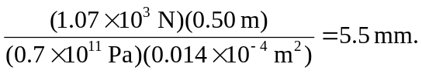

b) Using the same equations, at the top the force is 830 N, and the elongation is 0.0042 m.

